**LAB # 01**

**COMPUTER FOUNDAMENTAL LAB**



**Batch # 23**

**Computer Fundamental Lab**

Submitted by: **AWAIS SADDIQUI**

Registration No: **50620**

Class Section: **A**

“On my honor, as student of University of Engineering and Technology, I have neither given nor received unauthorized assistance on this academic work.”

Submitted to:

**Engr. Abdullah Hamid**

(November 29, 2021)

**Department of Computer Systems Engineering**

**University of Engineering and Technology, Peshawar**

# **Processor history And Storage devices**

**(1) Computer Hardware:**

The physical parts of a computer such as central processing unit (CPU), monitor, mouse, keyboard and data storage etc are called computer hardware.

***Processor:***

A processor is the logic circuitry that responds to and processes the basic instructions that drive a computer.

1. **Old Use processors:**

* ***1999 – Athlon:***

AMD launched Athlon on June 23. It was built using 37 million transistors and achieved a clock speed of about 800 MHz It was the first processor to reach the speed of 1 GHz.

* ***2003 Pentium M:***

This processor was a mobile single-core processor from Intel. It was designed with a clock speed of 2.26 GHz. Two processors were developed under this family, namely Baines, Dothan.

* ***2006 – Core 2:***

Intel Core 2 brand, launched on July 27, 2006, was also known as

E6320.The clock speed was achieved up to 3.5 GHz. The processors launched under this family were single-core, dual-core and quad-core.

1. **New Use Processors:**

* ***2011- Sandy Bridge:***

This Intel microarchitecture-based products were launched in 2011. It has achieved a 32-nanometer die manufacturing. It includes Intel Quick sync that is a hardware support for video encoding and decoding.

* ***2013-Core i-Series – Haswell:***

Intel updated its Core i-Series of processors in 2013 with the debut of the 22 nm Haswell micro-architecture, which replaced the 2011 Sandy Bridge. Haswell scaled up to 18 cores with the Haswell-EP line of Xeon processors, up to 5.69 billion transistors and clock speeds of up to 4.4 GHz.

* ***Intel Core i5 and i7:***

Intel launches 8th generation of Intel Core i5 and i7 processors with Radeon RX Vega M graphics at CES 2018.

* ***2021- Apple A14 Bionic:***

The Apple A14 Bionic is a System on a Chip. It was announced late 2020 and offers 6 cores divided in 2 performance cores (Firestorm) and four power efficiency cores.

**(2) Storage Devices:**

A storage device is any hardware capable of holding information either temporarily or permanently.

* ***USB:***

A USB flash drive is a data storage device that includes flash memory with an integrated USB interface.

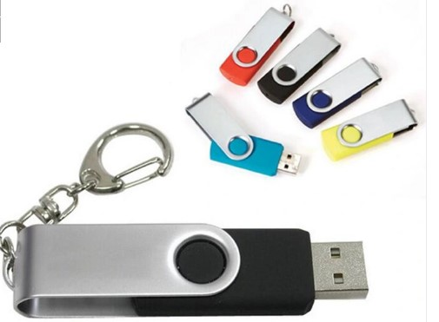

* ***Floppy Disk:***

The floppy disk drive is a removable magnetic storage medium that allows recording of data.

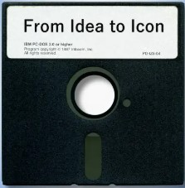

* ***SD Cards:***

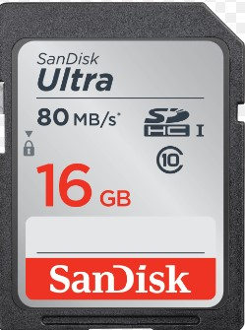 SD card is a type of memory card typically used in digital cameras and other portable devices.

* **Magnetic Storage:**

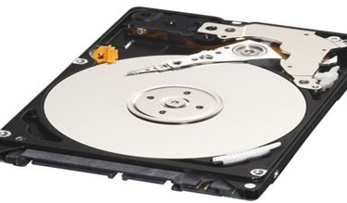 Magnetic storage is the storage of data on a magnetized medium. Magnetic storage uses different patterns of magnetization to store data and is a form of non-volatile memory.

* ***Hard Disk:***

Hard disks are flat circular plates made of aluminum or glass and coated with a magnetic material. Hard disks for personal computers can store terabytes (trillions of bytes) of information. Data are stored on their surfaces in concentric tracks

